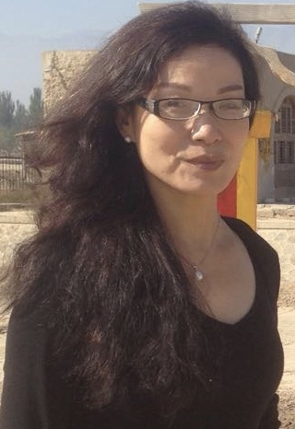

**Rongjing Zhang**

**China Liaison Director**

Rongjing “Ahlai” Zhang graduated from China’s Fujian Normal University, where she later became a professor, with a Bachelor of Education degree.

Ahlai was the famous Fujian Province “No. 9” national basketball league competitor. She also competed on their national track team. Her love of young people made her a popular teacher, and basketball and track coach.

Her career in sports and education has been recognized by the Fujian Ministry of Culture and Education with whom she has maintains a close relationship.

Ahlai is skilled in “healthy body, healthy mind” practices, which include being a yoga master, Tai Chi, massage, and acupuncture practitioner. After moving to Colorado in the United States, Ahlai organized and participated in marathons, bicycle races, and community awareness projects. She became a hotelier serving guests from all around the world.

Ahlai’s vast multi-national experience has honed her bridge-building strengths and cross-cultural skills. Her energetic creative personality has made her a highly sought-after child mentor. This outgoing style helps her connect with students, allowing her to help them adapt, integrate and seize opportunities in a new country.

Ahlai also loves cooking regional dishes and is an accomplished jewelry maker.